

Student Name | Gideon kibet Rono
Admission Number | BSCCS/2024/60885
Course | Bachelor of Science in Computer Science
Unit Code | BIT4139
Unit Name | Ethical Hacking and Counter measures
Lecturer | Michael Nyoro
Semester / Year | 2026

| Week 6-7 |
Ethical Hacking and Penetration Testing

Contents
Week 6: Vulnerability Assessment and Scanning 2
Fig 1. Network discovery 2
Fig 2. Network scanning 3
Fig 3. Service running discovery 3
Fig 4. Vulnerability assessment 4
Week 7: Vulnerability Assessment and Scanning 7
OWASP ZAP assessment 7
Test 1: Authentication 7
Test 2: Broken Access Control (OWASP A01) 8
Test 3 SQL Injection Check (Safe Observation) 9
Test 3. vulnerability assessment using linux tools 10
3.1 Installation of OWASP ZAP 10
3.2 scanning website using Zaproxy in attack mode 11
3.3 Identifying vulnerabilities from zaproxy alerts 12
3.4 report and analysis 12
1.SQL injection 12
2. Content Security Policy (CSP) Header Not Set 13

Week 6: Vulnerability Assessment and Scanning

Fig 1. Network discovery

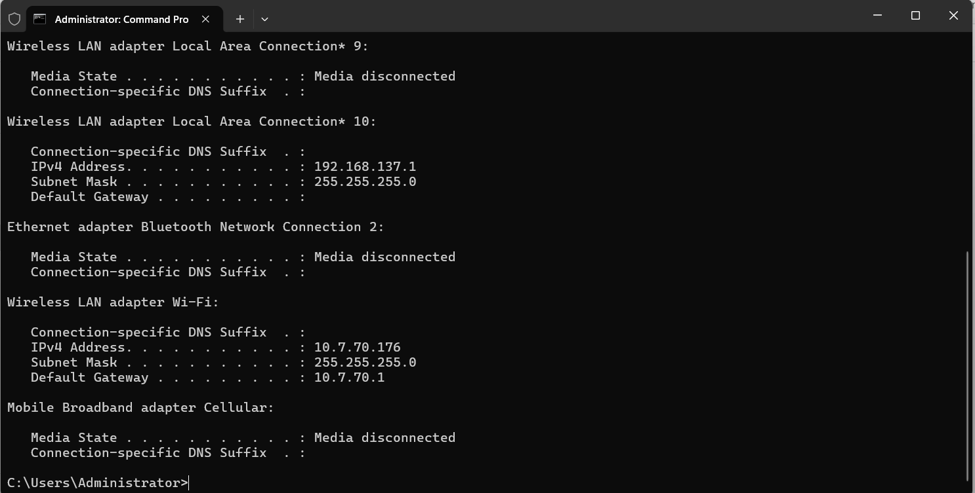

I ran an IP config command on CMD to find networks on my local machine

Fig 2. Network scanning
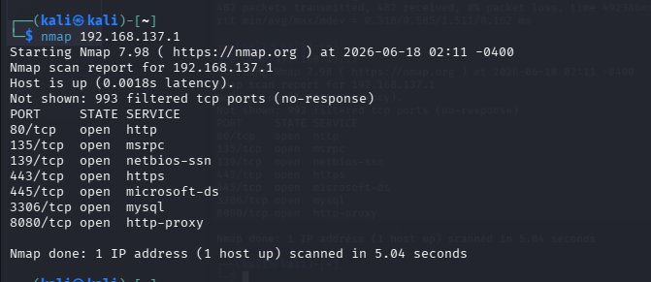

Fig 3. Service running discovery

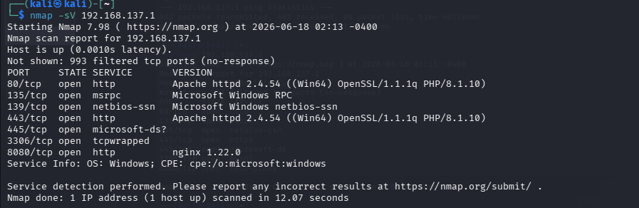

I scanned the ipv4 address of my local machine to detect services running on the network

Fig 4. Vulnerability assessment

Tools: Nikto

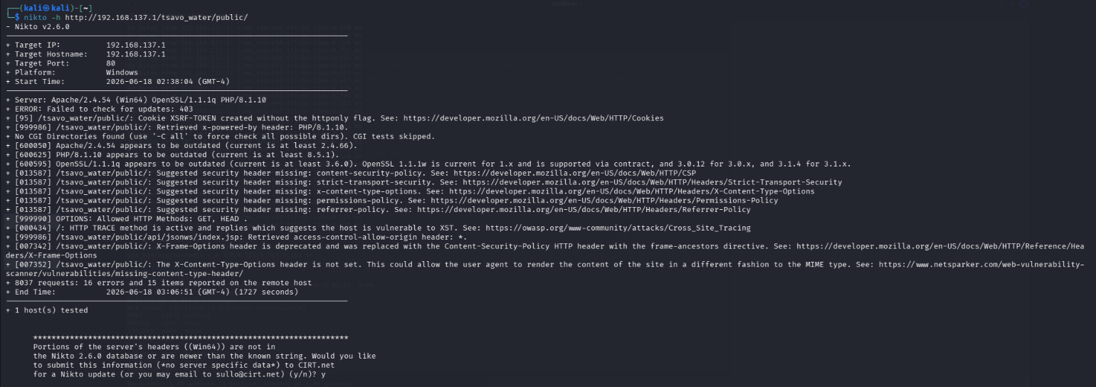

Key Findings from the Nikto Scan

1. Missing HTTP Only Flag on Cookie
Nikto found that the XSRF-TOKEN cookie was created without the HTTP Only flag.

Risk: Medium

Impact:
If a Cross-Site Scripting (XSS) vulnerability exists, malicious scripts may be able to access the cookie.

Recommendation:
Configure cookies with the HTTP Only attribute.

2. Technology Information Disclosure
The server reveals:
- Apache 2.4.54
- PHP 8.1.10
- OpenSSL 1.1.1

Risk: Low
Impact:
Attackers can identify software versions and search for known vulnerabilities.

Recommendation:
Remove or minimize server version disclosure headers.

3. Outdated Software Components
Nikto reported:
- Apache 2.4.54 outdated
- PHP 8.1.10 outdated
- OpenSSL 1.1.1q outdated
Risk: Medium
Impact:
Older versions may contain publicly known vulnerabilities.
Recommendation:
Update Apache, PHP, and OpenSSL to supported versions.

4. Missing Security Headers
The following headers are missing:
- Content-Security-Policy (CSP)
- Strict-Transport-Security (HSTS)
- X-Content-Type-Options
- Permissions-Policy
- Referrer-Policy
Risk: Medium
Impact:
Missing security headers increase exposure to attacks such as XSS, MIME sniffing, clickjacking, and information leakage.
Recommendation:
Implement appropriate HTTP security headers.

5. HTTP TRACE Method Enabled
Nikto reported:

HTTP TRACE method is active and replies which suggests the host is vulnerable to XST.

Risk: Medium

Impact:
TRACE can potentially be abused in Cross-Site Tracing attacks.

Recommendation:
Disable the TRACE method in Apache configuration.

6. Wildcard CORS Configuration

Nikto detected:

access-control-allow-origin

Risk: Medium

Impact:
Allows any domain to access resources, potentially increasing attack surface.

Recommendation:
Restrict CORS access to trusted domains only.

Risk Assessment Table
Vulnerability | Risk Level
Missing HTTP Only Cookie Flag | Medium
Information Disclosure | Low
Outdated Software Components | Medium
Missing Security Headers | Medium
HTTP TRACE Enabled | Medium
Wildcard CORS Configuration | Medium

Student Reflection (week 6)
During this practical, I performed a vulnerability assessment on the Tsavo Water Delivery System hosted locally on a Laragon server. Using Nmap and Nikto, I identified several security weaknesses, including outdated software versions, missing security headers, information disclosure, and insecure HTTP configurations. The exercise improved my understanding of web application security assessment and demonstrated how security misconfigurations can expose systems to potential attacks. This practical reinforced the importance of regular vulnerability scanning, secure server configuration, and implementing security best practices before deploying web applications to production environments.

Week 7: Vulnerability Assessment and Scanning
Tools
1.Browser Firefox)
2.Browser Developer Tools
3.OWASP ZAP

OWASP ZAP assessment

Test 1: Authentication

Attempted to log in with invalid credentials.

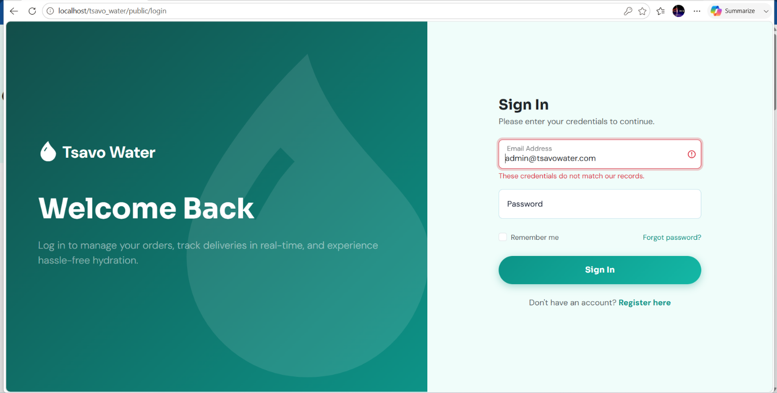

Result
The application displayed "These credentials do not match our records."
Access to the system was denied.

Test 2: Broken Access Control (OWASP A01)

Test Performed
Logged out of the administrator account and Attempted to access protected URLs directly.

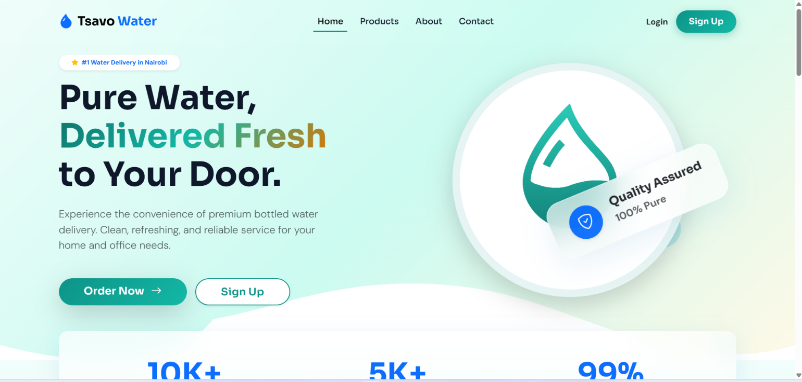

Result
The application redirected the user to the public home page instead of allowing access to the dashboard.

Test 3 SQL Injection Check (Safe Observation)

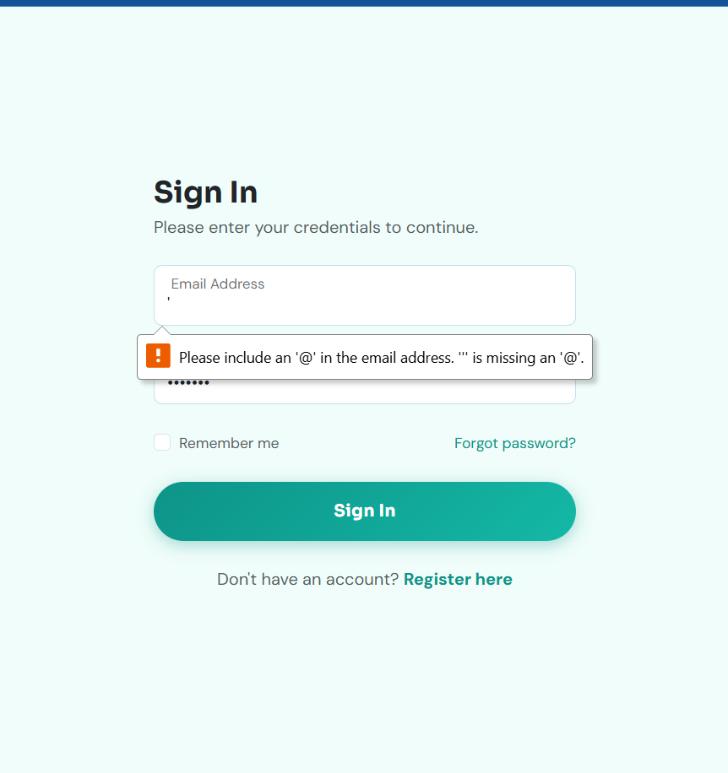

Assessment
OWASP Category: A03 – Injection

Test Performed
Entered a single quote (') into the email field.

Assessment

Pass -Client-side validation prevented malformed input from being submitted.

Test 3. vulnerability assessment using linux tools

3.1 Installation of OWASP ZAP

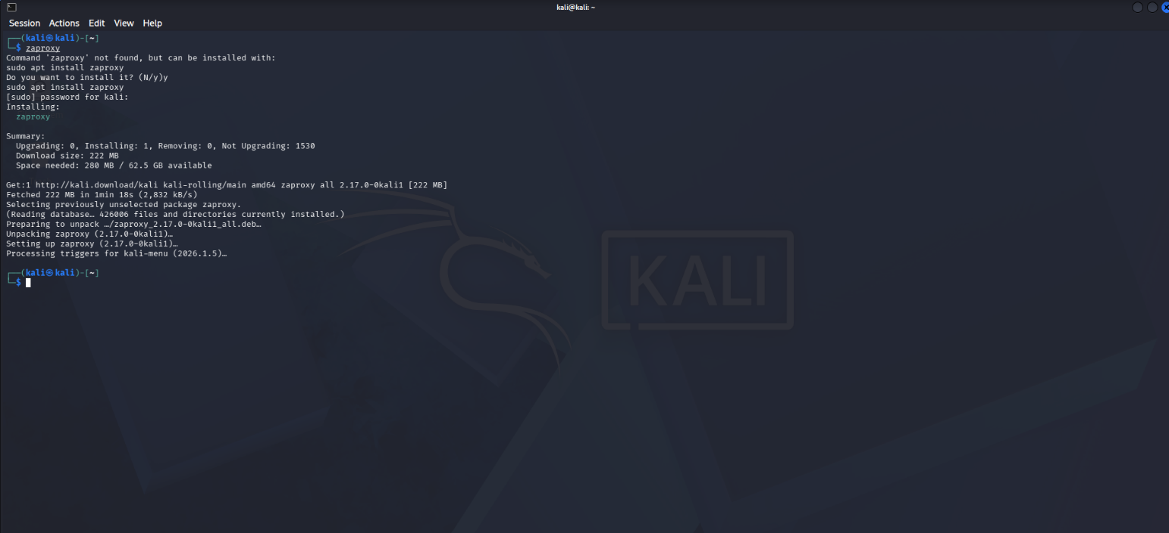

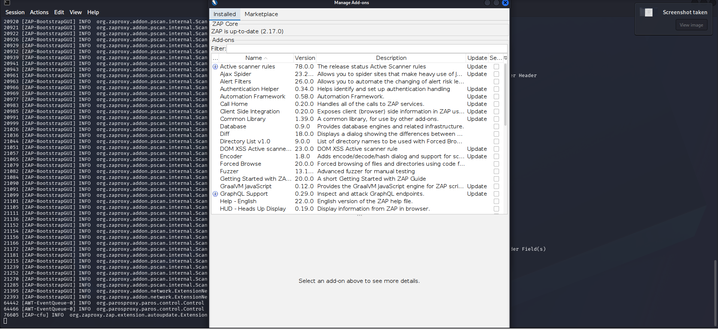

3.2 scanning website using Zaproxy in attack mode

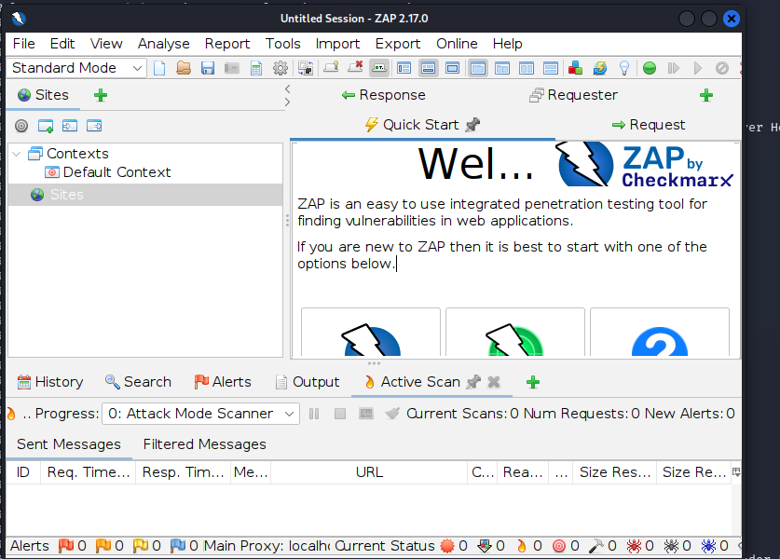

3.3 Identifying vulnerabilities from zaproxy alerts

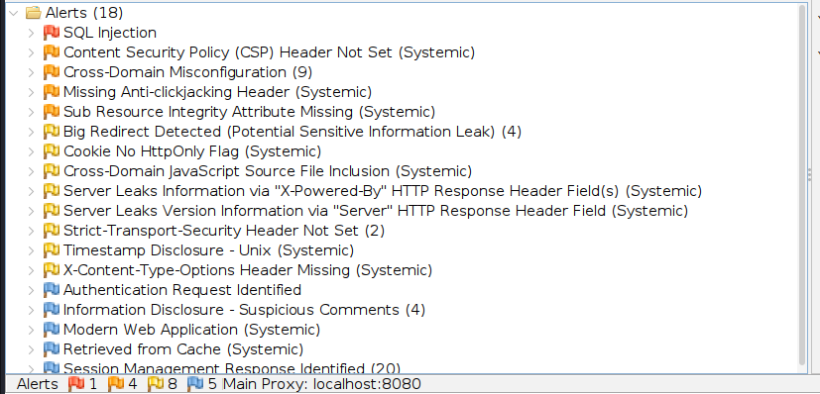

report and analysis

1.SQL injection
OWASP ZAP identified a potential SQL Injection vulnerability within the application. This type of vulnerability may allow attackers to manipulate SQL queries if user input is not properly handled.



2. Content Security Policy (CSP) Header Not Set

The application does not implement a Content Security Policy header.

Risk

This increases the likelihood of Cross-Site Scripting (XSS) attacks.

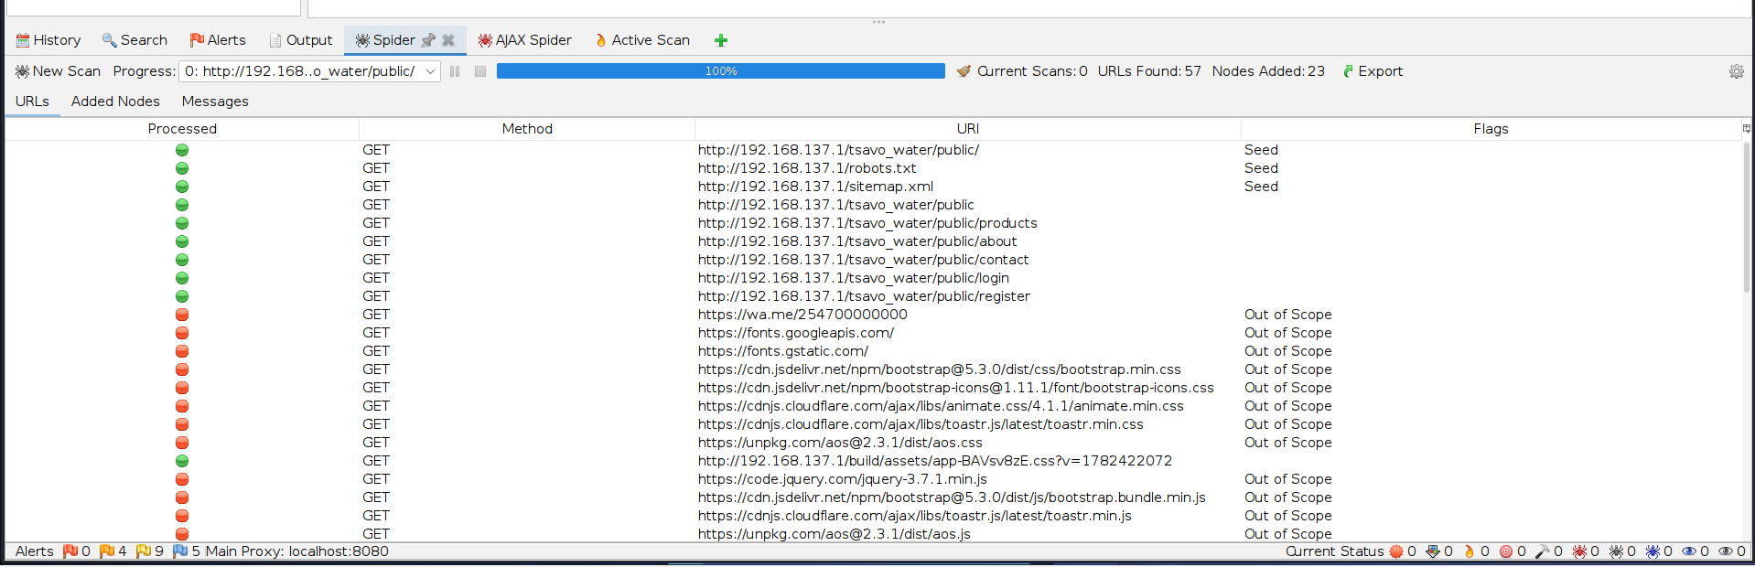

Reflection
During this week's practical, I learned how to use OWASP ZAP to assess the security of a web application. The scan helped identify vulnerabilities such as missing security headers and a potential SQL injection. I also learned the importance of verifying automated scan results and applying appropriate security measures to improve application security.

